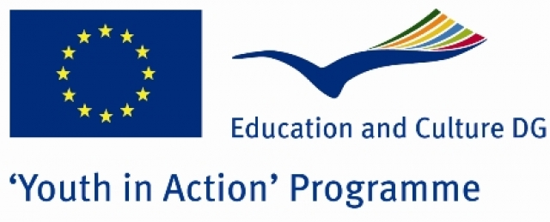

PROJECT DETAILS

BROADEN YOUR HORIZON

Action 1.1. Youth in Action Programme
Balıkesir-Gönen
Turkey
17-24 October 2010

General Context of the project:

'BROADEN YOUR HORIZON' aims to find out the similarities and differences of the problems of the rural area teenagers from different cultural backgrounds. During this youth project teenagers will find the chance to express their socialization problems and try to find out possible solutions to them.In addition,this project will not only let them feel they are not the only ones having this problem in this world but also introduce their countries and traditions to the peers.This youth project that will be held in Gönen-Balıkesir-Turkey will let 24-30 participiants from 3 different countries observe the situation in a real environment.By this way ,ideas will be shared in an international atmosphere and results will be disseminated via posters and web site. Cultural nights and social activities will make the participants know more about each culture.



_______________________________________________________________

Activities:

- Ice-breaker games to know eachother better
- Presentations,discussions,workshops,
- Special interest group works
- Cultural nights of all the participant countries
- Trip to another city

Target Group:

Participants must be over 18 and can be till 25.Group leaders can be older.As this project aims to search for the problems of the rural area teenagers it would be better if the participant groups come from these kind of areas.People who are creative ,open to international works and relationships will be suitable for this project

Funding:
Except for %30 of travel expenses, everything including %70 of travel expenses ,accommodation,transportation and food will be supplied by the Rainbow Group.

Who can apply?:
Organizations or grous of the 27 EU countries, Iceland, Norway and Liechtenstein can be applied for being a part of this project.
As the project will be applied to the Youth in Action Programme, we kindly ask you to send us your singed and stamped Part III via email to grouprainbow@yahoo.com

Deadline Date: 04.02.2010
After evaluating all the application forms, we will contact with accepted partners on the 5th of April.

Program of the project:
‘BROADEN YOUR HORIZON’
17-24 OCTOBER 2010
BALIKESİR-GÖNEN
TURKEY

PROJECT SCHEDULE
DAYS | MORNING |  | AFTERNOON |  | EVENING
 | 09:30 – 10:30 | 11:00 – 12:00 | 13:30 – 14:30 | 15:00 – 16:00 | 18:00-22:00
17 OCTOBER SUNDAY | Arrival of the participants & |  |  |  | Check-in for the hotel
17 OCTOBER SUNDAY | Tour in another city |  |  |  | Check-in for the hotel
18 OCTOBER MONDAY | Welcoming speeches and general presentations of the leaders of 3 countries |  |  |  | Cultural night of the first country
19 OCTOBER TUESDAY | General presentations | General presentations | General presentations | General presentations | Free time
20 OCTOBER WEDNESDAY | General presentations | General presentations | Forming special groups and topics | Forming special groups and topics | Cultural night of the 2nd country
21 OCTOBER THURSDAY | Special group works | Special group works | Special group works | Special group works | Free time
22 OCTOBER FRIDAY | Special interest group presentations | Special interest group presentations | Preparation of the group reports | Finalising the report for the website | Cultural night of the 3rd country
23 OCTOBER SATURDAY | Social activities
24 OCTOBER SUNDAY | Social activities

Contact : Sanem Dilbaz (Project Manager)

Email: grouprainbow@yahoo.com

Phone: +90 530 87293 92

